**Web App functional requirements**

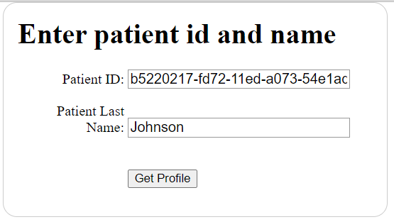

Figure Form input for the getPatientForm command

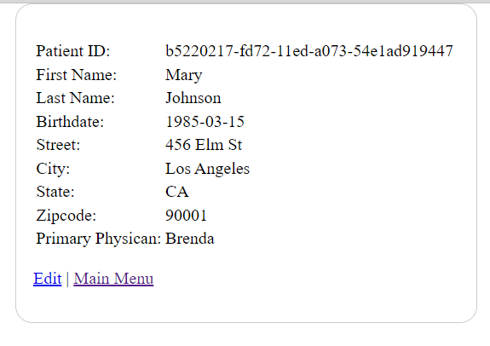

Figure Form output once you click ’get profile’ button

Figure 1 shows a form that gets a specific patient record based on the patient ID and the last name. Figure 2 is the result once you click on the ‘Get Profile’ button.

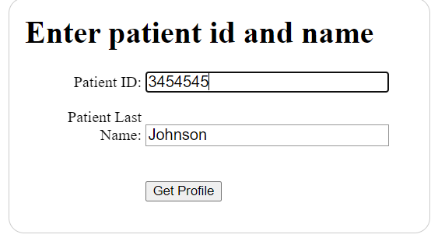

Figure Input for a patient ID that's not available

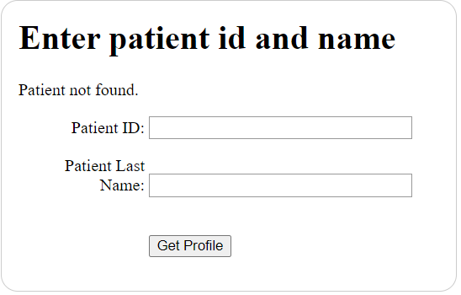

Figure Output showing patient not found.

Figure 3 and 4 show an instance where one inputs a patient ID that’s not in the database.

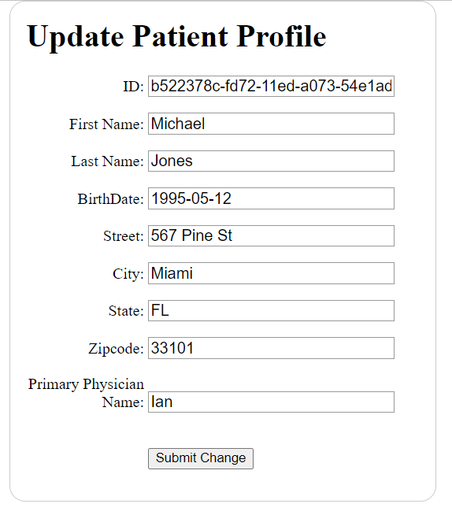

Figure Form for editting info of another patient UpdatePatientForm

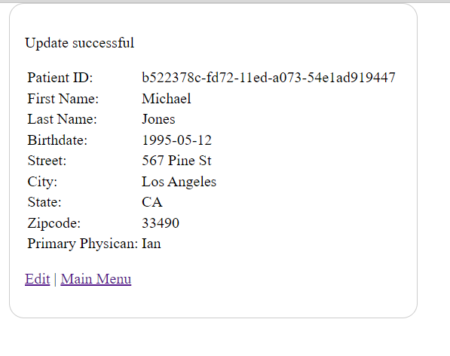

Figure Result after successful update

Figure 5 and 6 demonstrate the process of updating a patient profile. In this case, the zip code has been changed.

**Java JDBC Report Program**

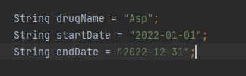

Figure Input to the java JDBC program.

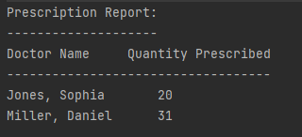

Figure Output of the program

In the java JDBC program, figure 7 shows the variables that were used to get the first and last names of the doctors that prescribed them and the total amount.

**SQL Script**

I have modified the script to allow defaults for some primary keys using UUID, FLOOR, and RAND functions. The script is on the assignment folder.